# **Planning and Progress Report**

**Group:** C1.027  
**Repository:** [AirNav-Logistics](https://github.com/DP2-C1-027/AirNav-Logistics)**Date:** February 15, 2025

### **Group Members:**

1. **Garcia de Tejada Delgado, Jose**
   * Role: Developer
   * Email: josgardel8@alum.us.es
2. **Peñaloza Friqui, Nora**
   * Role: Developer
   * Email: norpennfri@alum.us.es
3. **Niza Cobo, Manuel Jesús**
   * Role: Manager, Developer
   * Email: mannizcob@alum.us.es
4. **Gomez Claraco, Nicolas**
   * Role: Developer
   * Email: nicgomcla@alum.us.es
5. **Campos Diez, Lucia**
   * Role: Tester, Developer
   * Email: luccamdie@alum.us.es

## **Table of Contents**

1. **Executive Summary**
2. **Revision Table**
3. **Introduction**
4. **Planning Chapter**
   * Tasks Performed
   * Estimated Budget
5. **Progress Chapter**
   * Progress Records
   * Conflicts and Resolution
   * Cost Comparison
6. **Conclusions**
7. **Bibliography**

## 

## 

## 

## 

## 

## 

## 

## 

## 

## 

## 

## 

## **Executive Summary**

This report aims to present the analysis, planning, and progress of the *AirNav-Logistics* project, which is being developed to create a comprehensive logistics management system for charter flights at airports. The document details the completed tasks, the progress of features, and the estimated and actual budget. It also covers the working methodology, conflicts encountered during development, and a comparison of the estimated and real costs. The purpose is to ensure the project is progressing according to plan, within the allocated time and budget.

## **Revision Table**

|  |  |  |
| --- | --- | --- |
| **Revision** | **Date** | **Description** |
| 1 | 17/02/2025 | Creation of the analysis, planning, and progress report. |

## **Introduction**

This report outlines the analysis, planning, and progress achieved in the *AirNav-Logistics* project developed by group C1.027. The goal of this project is to create a system that will assist airports in managing resources for charter flights. The report is divided into two chapters: planning and progress, which include a detailed description of the assigned tasks, their execution, associated costs, and managed conflicts.

The structure of the report includes a breakdown of the tasks performed by each team member, an analysis of the costs, and a summary of the conflicts resolved during the project’s development.

## 

## 

## 

## 

## 

## 

## 

## 

## 

## 

## 

## 

## **Planning Chapter**

### **Tasks Performed:**

**→Individual requirements:**

**Task 1: Modify the anonymous menu**

* **Description:** The anonymous menu was modified to display an option that redirects the browser to the homepage of a favorite website, with the title formatted as: “〈id-number〉: 〈surname〉, 〈name〉”
* **Assigned to:** Lucía Campos (developer)
* **Planned Time:** 35 minutes
* **Actual Time:** 20 minutes

**Task 2:** Provide a link to the GitHub planning dashboard

* **Description**: A link was provided to the planning dashboard for reviewing the task statuses and project schedule.
* **Assigned to:** Lucía Campos (developer)
* **Planned Time:** 20 minutes
* **Actual Time:** 5 minutes

**Task 3: Planning and Progress Report**

* **Description**: Created the planning and progress report with all the required details.
* **Assigned to:** Lucía Campos (developer)
* **Planned Time**: 3 hours
* **Actual Time**: 4 hours

**Task 4: Analysis Report**

* **Description**: Produced the analysis report with the corresponding logs.
* **Assigned to:** Lucía Campos (developer)
* **Planned Time**: 3 hours
* **Actual Time**: 2 hours

**Task 5: Set up the workspace**

* **Description**: Configured the workspace for the project.
* **Assigned to:** Lucía Campos (developer)
* **Planned Time**: 1.5 hours
* **Actual Time**: 5.5 hours

**Task 6: Attend classes**

* **Description**: Attended 6 classes (5 theory class and 1 follow-up), each lasting 1.5 hours
* **Assigned to:** Lucía Campos (developer)
* **Planned Time**: 9 hours
* **Actual Time**: 9 hours

**Task 7: Meeting1**

* **Description**: First meeting where we expressed our expectations regarding the work and the selection of the manager.
* **Assigned to:** Lucía Campos (developer)
* **Planned Time**: 1.5 hours
* **Actual Time**: 1 hour

**Task 8: Meeting 2**

* **Description**: We share our progress and improvements for the first deliverable
* **Assigned to:** Lucía Campos (developer)
* **Planned Time**: 40 minutes
* **Actual Time**: 1 hour

**→Group requirements:**

**Task 9: Report on how you have set up your development configuration**

* **Description**: Created a report on how you have set up your development configuration.
* **Assigned to:** Lucía Campos (developer)
* **Planned Time**: 2 hours
* **Actual Time**: 2.5 hours

**Task 10: Planning and progress group report**

* **Description**: Created the planning and progress group report with all the required details.
* **Assigned to:** Lucía Campos (developer)
* **Planned Time**: 3 hours
* **Actual Time**: 4.5 hours

**Screenshots of Development Stages**

**1. Initial Task Definition in the "To Do" Lane**

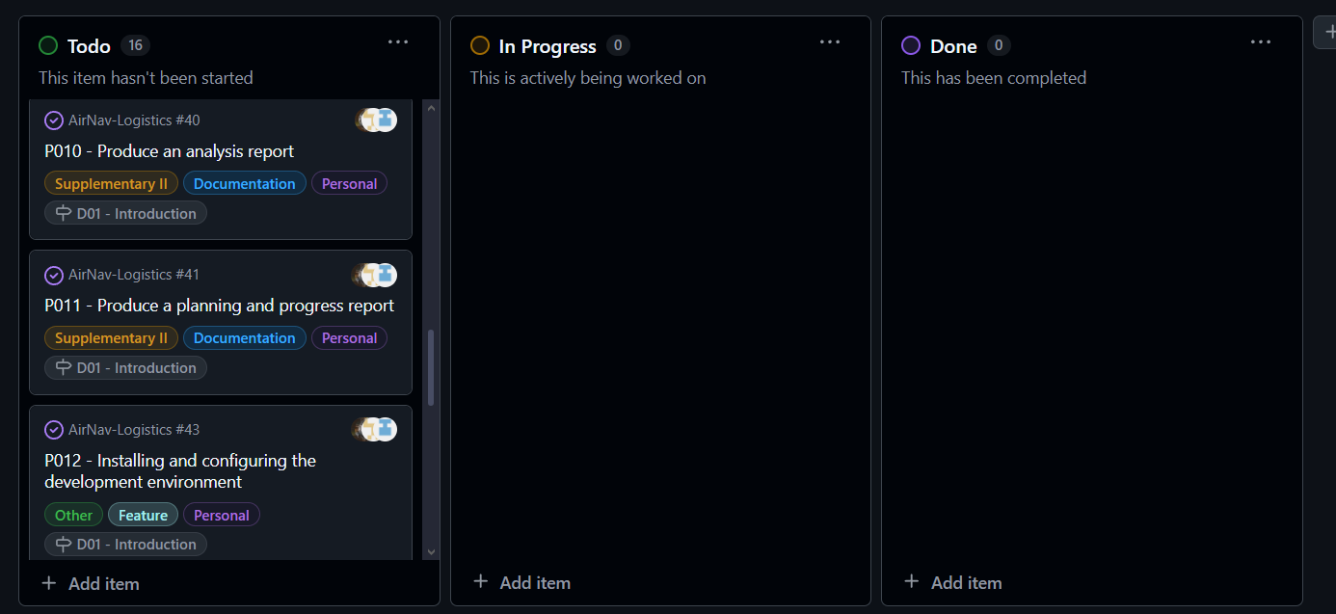

#### **2. Midway Through the Delivery: All Types of Tasks in Various Lanes**

#### **3. Final Task Completion in the "Done" Lane**

**Estimated Budget**

**Estimated hours by role:**

* **Modify the Anonymous Menu**: 35 minutes.
* **Provide a Link to the GitHub Planning Dashboard**: 20 minutes.
* **Planning and Progress Report**: 3 hours.
* **Analysis Report**: 3 hours.
* Set up the workspace: 1.5 hours.
* Attend classes: 9 hours.
* Report on how you have set up your development configuration: 2 hours.
* Planning and progress group report: 3 hours.
* Meeting1: 1.5 hours.
* Meeting 2: 40 minutes.

**Total Estimated Hours for Lucía Campos Díez:**  
**24.5 hours**

**Cost per role:**

**Developer (Lucía Campos Díez): €20/hour**  
**24.5 hours x €20 = €491.5**

**Amortization:**

* The amortization has been calculated using a linear method over three years, with an annual cost of €20.00 for the infrastructure used.

**Total Estimated Cost:**

* **Developer: €491.5**
* **Amortization: €20.00**
* **Total Estimated: €511.5**

**Progress Chapter**

#### **Progress Records**

|  |  |  |  |
| --- | --- | --- | --- |
| **Team Member** | **Performance Indicators** | **Value** | **Description** |
| Lucía Campos Díez | Task Completion | Good | All tasks completed on time and within the estimated time. |

### **Reward/Admonishment**

No formal reward was applied, but Lucía's efficient completion of tasks is noted as a positive contribution to the team's success.

### **Conflicts and Resolution**

No major conflicts arose during development. The team members worked collaboratively to address any technical challenges independently.

#### **Cost Comparison**

|  |  |  |
| --- | --- | --- |
| **Cost Component** | **Estimated Cost** | **Real Cost** |
| **Developer (Lucía Campos)** | **€491.5** | **€560** |
| **Amortization** | **€20.00** | **€20.00** |
| **Total Cost** | **€511.5** | **€580** |

### 

## 

## 

## **Conclusions**

The AirNav-Logistics project is progressing smoothly, with all tasks completed within budget and timeframe. The modifications have improved UI coherence, and documentation is aligned with project expectations.

## 

## **Bibliography**

Intentionally blank.